Westgate Used Racket Selling Service

Please complete this form giving details about the racket you wish to sell and return this to the Badminton Centre Manager.
SECTION 1 - Detials
Seller’s Name |  | Phone No.
Email
Make of Racket |  | Model
Colour/s
Asking price*
* Westgate Badminton Centre reserves the right to provide up to 10% discount – please take this into account
SECTION 2 - Disclaimer
At this stage, any damage to the racket must be reported. Please state below any damage to the racket and/or strings that you are aware of and indicate the position. Please note: all rackets will be checked thoroughly before agreeing to sell it on your behalf.
Nature of damage

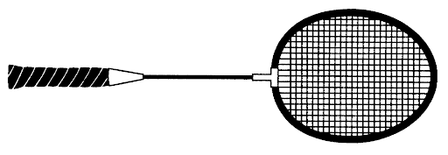
SECTION 3 – Terms and Conditions
The racket is checked for any minor damage (hairline cracks, missing grommets etc.) by Westgate badminton and a new (black) grip is fitted to the racket. All rackets must be fully strung. Westgate BC will not accept any rackets showing clear and obvious signs of wear and tear. Damaged rackets will not be accepted.
The racket will be displayed in the shop and advertised as 'Sold As Seen' therefore the onus is on the buyer to check the racket over before purchasing it.
Details of the racket will also go onto the HBA website's Westgate Shop page so the stock can be viewed online.
Westgate sells the racket on behalf of the owner and then pays the owner the sale price, less 25% commission.
There are no warranties with the rackets due to the number of defects that a racket could develop over time and rackets are NOT available to try out before purchase.
Signed (seller) |  | Signed  (centre manager)

Date

